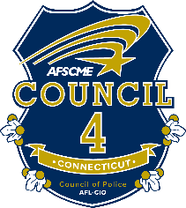

Steward Training & Use of Force
Date: Tuesday, February 6, 2018
Time: 10:00 a.m. to 3:00 p.m.
Where: Port 5, 69 Brewster Street, Bridgeport, CT
*Continental Breakfast and Lunch will be provided*

Please fill out the attached registration form and send it to Stephanie at swise@council4.org.
If you have any questions please call (860) 612-3803

COUNCIL 4 STEWARD AND USE OF FORCE TRAINING CLASS
FEB. 6, 2018 – BRIDGEPORT, CT

MEMBERS ATTENDING:

________________________________________

________________________________________

________________________________________

________________________________________

________________________________________

________________________________________

DEPARTMENT _________________________________ LOCAL #:_________________

DEPARTMENT ADDRESS__________________________________________________

__________________________________________________________________________

TELEPHONE_______________________ E-MAIL ______________________________

Please mail or e-mail Registration Form to:

AFSCME, Council 4
444 East Main Street
New Britain, CT 06051
Attention: Stephanie Wise
swise@council4.org

