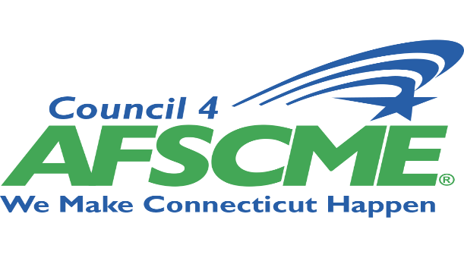

HOLD THE DATE AND REGISTER!
July 12,2021 0900-1000 & 1800-1900 ZOOM

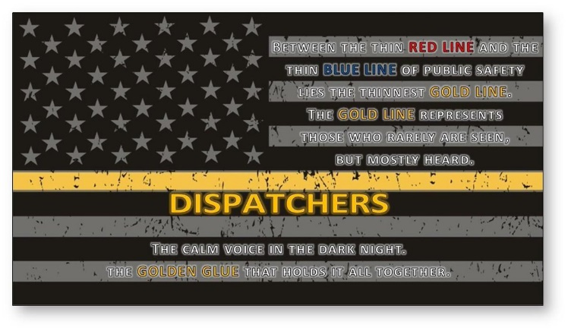
9-1-1 TELECOMMUNICATOR UNION WORKGROUP
Purpose of Workgroup: Network with Council 4, AFSCME 9-1-1 Telecommunicators, share stories, discuss issues/concerns, common concerns, best practices for a strong membership in a stressful classification.
AGENDA
Welcome
Introductions
Council 4’s Communiciation Team
Organizing and Education
Political Team Intro, Updates, & Regionalization
What Needs to be done
What do you want to see included in this workgroup
Next Workgroup Meeting
Your Comments
To register, please submit form to KMartinez@council4.org
NAME_________________________________________ LOCAL#___________________
HOME EMAIL ADDRESS____________________________________________
CELL PHONE #___________________________
444 East Main Street
New Britain, CT 06051 www.council4.org

